DYNAMIC ROUTING AND POWER CONTROL IN WSNs
WITH K-MEANS AND Q-LEARNING USING
ARTIFICIAL INTELLIGENCE

¹AUTHOR’S NAME (REENA S), ²CO-AUTHOR’S NAME (SHREE HARINI S),
³CO-AUTHOR’S NAME(SOUNDARYA AL)

¹Author’s Designation (Student), College name/University name (K.Ramakrishnan College of Engineering), College address (Samayapuram,Trichy,TamilNadu-621112)
²Co-Author’s Designation (Student), College name/University name (K.Ramakrishnan College of Engineering), College address(Samayapuram,Trichy,TamilNadu-621112)
³Co-Author’s Designation (Student), College name/University name (K.Ramakrishnan College of Engineering), College address(Samayapuram,Trichy,TamilNadu-621112)

Email: ¹Author’s email id (reenasenthilkumar2005@gmail.com), ²Co-Author’s email id (shreeharini1092004@gmail.com), ³Co-Author’s email id (soundarya282004@gmail.com)

Contact: ¹Author’s contact no. (+91 7094224101), ²Co-Author’s contact no. (+91 8754146930),
³Co-Author’s contact no.(+91 9360711948)

Abstract: Wireless Sensor Networks (WSNs) are widely used in real-world applications such as agriculture, environmental monitoring, and smart cities. However, sensor nodes have limited battery power, making energy efficiency a major challenge. To address this issue, this project proposes an intelligent energy-efficient model using K-Means clustering and Q-Learning. K-Means clustering groups nearby sensor nodes to reduce communication distance and balance energy consumption. Q-Learning, a reinforcement learning technique, is used to select optimal routing paths dynamically based on energy levels and network conditions. Additionally, redundant data transmission is avoided by sending data only when changes occur, further saving energy. The proposed approach significantly improves network lifetime, reduces energy consumption, and ensures reliable data delivery. This model is suitable for real-world WSN applications where long-term and low-maintenance operation is required.
Index terms: Wireless Sensor Networks, Energy Efficiency, K-Means Clustering, Q-Learning, Intelligent Routing, Network Lifetime Optimization.

- INTRODUCTION

Wireless Sensor Networks (WSNs) consist of a large number of small sensor nodes that are used to monitor physical and environmental conditions such as temperature, humidity, pressure, and motion. These sensor nodes collect data from the environment and transmit it to a base station for further processing. WSNs are widely used in real-world applications including agriculture monitoring, environmental observation, healthcare systems, smart cities, and industrial automation.

Despite their wide usage, sensor nodes suffer from limited battery power, processing capability, and communication range. Since replacing or recharging batteries is often difficult or impossible in remote areas, energy efficiency becomes a critical challenge in WSNs. Most of the energy in a sensor node is consumed during data transmission, especially when redundant or unnecessary data is sent frequently.

To overcome these challenges, intelligent techniques are required to optimize energy consumption and extend network lifetime. Clustering is an effective approach where sensor nodes are grouped, and a cluster head manages communication within each group. In addition, adaptive routing techniques can help in selecting energy-efficient paths for data transmission. This project introduces an AI-based approach that combines K-Means clustering and Q-Learning to improve energy efficiency, reduce redundant communication, and ensure reliable data delivery in Wireless Sensor Networks.

- K-MEANS BASED CLUSTERING

Clustering is an effective technique in Wireless Sensor Networks (WSNs) to improve energy efficiency and scalability. In the proposed system, K-Means clustering is used to group sensor nodes based on their physical location in the network. Each cluster consists of a set of nodes with one node selected as the Cluster Head (CH), while the remaining nodes act as cluster members. The main goal of clustering is to reduce the communication distance between nodes and the cluster head, thereby saving energy and balancing the load across the network.
The K-Means algorithm works by first selecting K initial centroids, which represent the centers of the clusters. Each sensor node is assigned to the cluster whose centroid is nearest, typically based on Euclidean distance. After assignment, the centroids are recalculated as the mean position of all nodes in the cluster. This process repeats iteratively until the cluster members remain stable, and the positions of the centroids converge. This ensures that nodes are grouped optimally to minimize intra-cluster distance and communication cost.
Within each cluster, the Cluster Head is responsible for collecting data from the member nodes, aggregating it, and forwarding it to the base station, either directly or via other cluster heads. By using K-Means clustering, the network achieves balanced energy distribution, preventing early depletion of any individual node. Additionally, clustering allows the network to scale efficiently, as new nodes can be added and assigned to clusters without disrupting the overall communication structure.
The use of K-Means in this project ensures that energy consumption is minimized, network lifetime is extended, and the communication process becomes more organized and reliable. This clustering mechanism provides the foundation for the Q-Learning-based dynamic routing, as the routing decisions are performed at the cluster head level, making the entire network more adaptive and energy-efficient.
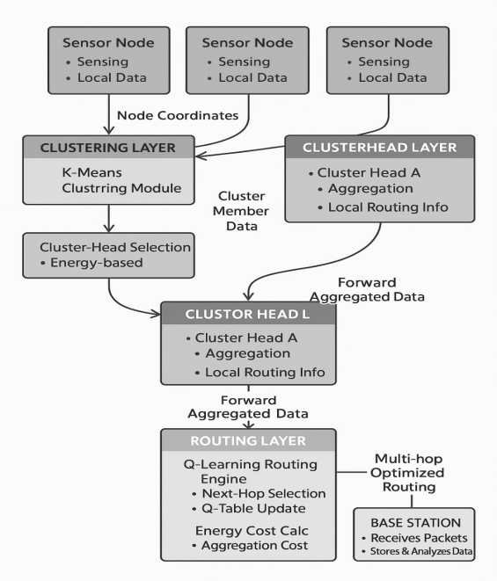

Figure 1: Proposed System Block Diagram.

- Q-LEARNING BASED ROUTING

In the proposed system, Q-Learning, a type of reinforcement learning, is used to dynamically select the most energy-efficient routing paths in the Wireless Sensor Network (WSN). After K-Means clustering forms clusters, the Cluster Heads (CHs) are responsible for sending aggregated data to the Base Station (BS). Instead of using fixed or random routes, Q-Learning allows CHs to learn the optimal path over time by interacting with the network environment.
Each CH acts as an agent, which observes the network state, including factors such as the residual energy of neighboring nodes, distance to the next hop, and network congestion. The agent can choose an action, i.e., the next-hop node to forward the data. After each action, the agent receives a reward based on the energy cost, successful packet delivery, and reliability of the selected path. Positive rewards are given for selecting energy-efficient nodes and reliable routes, while negative rewards are applied for low-energy or congested paths. Over multiple iterations (or rounds), the Q-Learning agent updates its Q-table, gradually learning the best possible routing strategy for each network state.
This dynamic learning approach enables the network to adapt to changing conditions, such as node energy depletion, link failures, or newly added nodes. It avoids routing through nodes with low energy, reduces overall energy consumption, and balances load across the network. Combined with K-Means clustering, Q-Learning ensures that data is delivered to the base station efficiently, with minimal delay and maximal network lifetime. This intelligent routing mechanism makes the WSN more robust, scalable, and suitable for real-world applications where manual intervention is not feasible.
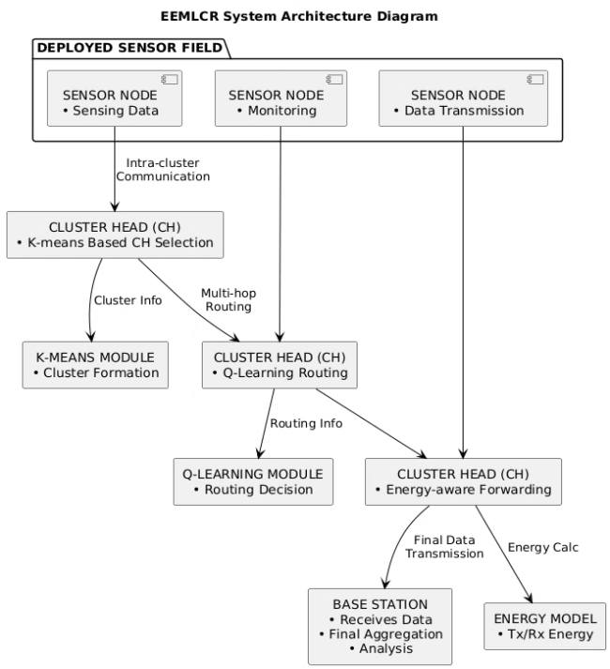

Figure 2: Architecture Diagram

- DYNAMIC POWER CONTROL

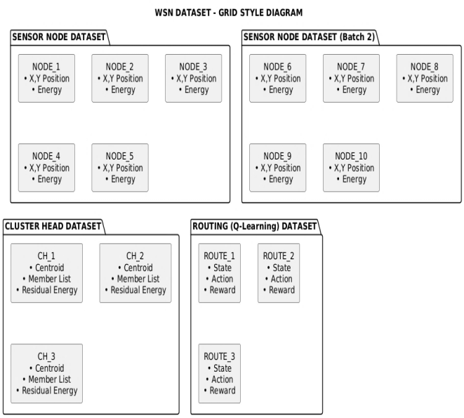

Figure 3: Dataset
In Wireless Sensor Networks (WSNs), sensor nodes operate with limited battery power, and excessive communication can quickly drain their energy, leading to early node failure. To address this challenge, the proposed system incorporates dynamic power control to optimize energy consumption during data transmission. Dynamic power control enables sensor nodes to adjust their transmission power based on the distance to the receiving node, ensuring that only the minimum required energy is used for successful communication.
For short-distance communication within a cluster, nodes transmit data using low transmission power, thereby conserving energy. In contrast, for longer-distance or multi-hop communication toward the base station, higher transmission power is applied only when necessary. This adaptive adjustment prevents unnecessary energy expenditure caused by fixed high-power transmissions and significantly reduces overall power consumption.
By continuously adapting transmission power according to network conditions and communication range, dynamic power control helps balance energy usage among nodes, prevents rapid battery depletion, and prolongs node and network lifetime. When integrated with K-Means clustering and Q-Learning-based routing, dynamic power control ensures efficient data forwarding, avoids overloading cluster heads, and enhances the network’s ability to adapt to changing conditions. This makes the system well-suited for real-world applications such as smart agriculture, environmental monitoring, and industrial IoT.

- NETWORK MODEL

The Wireless Sensor Network (WSN) considered in this project consists of a large number of homogeneous sensor nodes randomly deployed over a defined geographical area. Each sensor node is equipped with a sensing unit, a processing unit, a wireless transceiver, and a limited, non-rechargeable battery. A single Base Station (BS) with high computational capability and unlimited energy is placed either inside or outside the sensing field. Sensor nodes periodically sense environmental parameters, such as temperature, humidity, or motion, and transmit the collected data to the BS.
To improve scalability and energy efficiency, the network is organized using a cluster-based architecture. Nodes that are physically close to each other are grouped into clusters using the K-Means clustering algorithm. Within each cluster, one node is selected as the Cluster Head (CH), while the remaining nodes act as cluster members. Cluster members send their sensed data to the CH, which performs data aggregation and forwards the processed information to the BS, either directly or via other CHs.
The network model assumes that nodes are stationary after deployment and have symmetric communication links. Each node keeps track of its residual energy and neighboring nodes through periodic information exchange. Time is divided into rounds, during which clustering, routing, and data transmission are repeated to maintain balanced energy usage and extend network lifetime. This model ensures that the network can adapt to node failures, varying energy levels, and dynamic routing requirements, providing a robust foundation for energy-efficient communication using AI techniques.
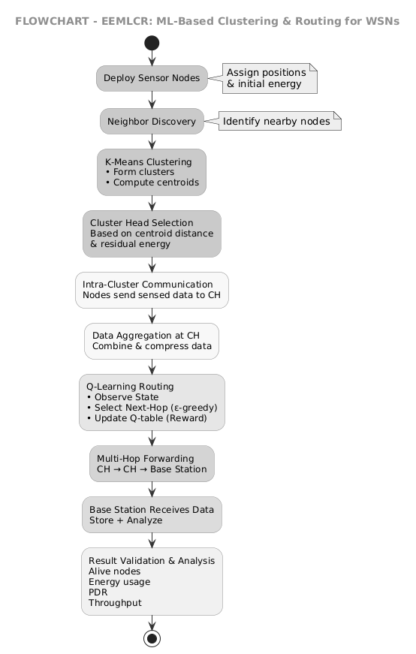

Figure 4: Flowchart
- RESULTS

The proposed system was implemented to evaluate the effectiveness of dynamic routing and power control in Wireless Sensor Networks using K-Means clustering and Q-Learning. K-Means clustering efficiently grouped sensor nodes based on their distance, which reduced intra-cluster communication cost and balanced the load among cluster heads. This clustering approach minimized unnecessary long-distance transmissions and improved overall energy utilization in the network.

Q-Learning enabled the system to dynamically select the most energy-efficient routing paths by learning from network conditions such as residual energy, distance, and node availability. Over time, the learning agent avoided low-energy and congested nodes, resulting in more stable and reliable data transmission. The adaptive nature of Q-Learning allowed the network to quickly respond to node failures and changing topology without manual intervention.

Additionally, power control and redundant data suppression further reduced energy consumption by limiting unnecessary transmissions. The combined effect of intelligent clustering, dynamic routing, and power control significantly extended network lifetime and improved data delivery performance. These results demonstrate that the proposed AI-based approach outperforms traditional static routing methods and is well suited for real-world WSN applications.

CONCLUSION

This project proposed an AI-based approach for dynamic routing and power control in Wireless Sensor Networks using K-Means clustering and Q-Learning. K-Means efficiently grouped sensor nodes to reduce communication distance and balance energy consumption, while Q-Learning dynamically selected the most energy-efficient routing paths based on network conditions. The combined approach reduced unnecessary data transmission, improved energy efficiency, and extended the overall network lifetime, making the system adaptive, reliable, and suitable for real-world WSN applications.

REFERENCES

[1] Wan-Kyu Yun and Sang-Jo Yoo, ‘‘Q-Learning-Based Data-Aggregation-AwareEnergy-Efficient Routing Protocol for Wireless Sensor Networks”, IEEE International conference,2021.
[2] Muhammad Akram, Sibghat Ullah Bazai, Muhammad Imran, “EEMLCR: Energy-Efficient MachineLearning-Based Clustering and Routing for Wireless Sensor Networks”, IEEE International conference,2025.
[3] Salim El Khediri, Awatef Benfradj, “Integration of artificial intelligence (AI) with sensor networks: Trends, challenges, and future directions”, Journal of King Saud University - Computer and Information Sciences,2024.
[4] Huda Salih Abd, Asaad S Daghul, “An Energy-Efficient Scheduling and Routing Protocol Based on Q-Learning for WSN”, Asian Journal of Computing and Engineering Technology,2025.
[5]Yan Wang, Ke Deng, Yongli Ren, Jeffrey Chan, “Reinforcement Learning for Tackling Energy-saving and Energy-balance Dilemma of Cluster-based Routing Protocols in WSNs”, IEEE International conference,2024.

